Farming Assistant System

DevOps Documentation

Team Members: Team Mentor:
Gaurav Mohanty Vishal Soni
Harshit Joshi
Manoj Kumar
Reema Kumari
Yash Raj

Tools used and its version: -

- Jenkins 2.249
- SonarQube 8.4.2
- Nexus Repository 3.27
- Tomcat 9.x

Step 1: Install Jenkins

- Download Jenkins from https://www.jenkins.io/download/
- Unlock Jenkins with administrator password

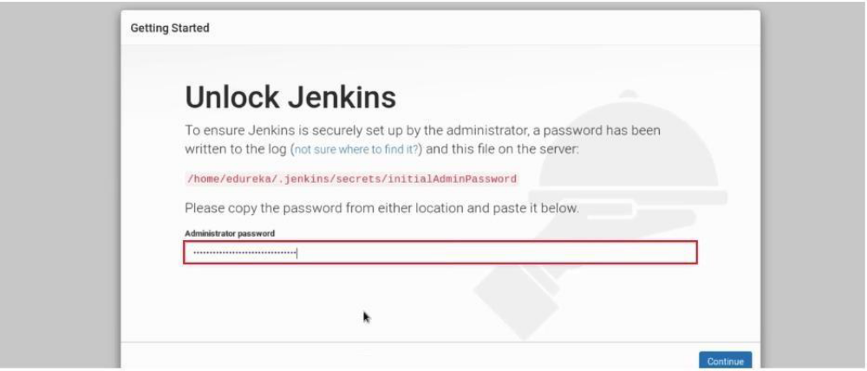

- Select the suggested plugins

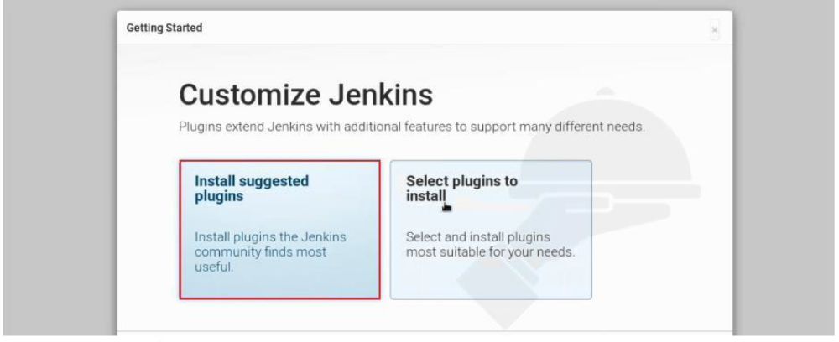

- Jenkins Started then create new jobs.
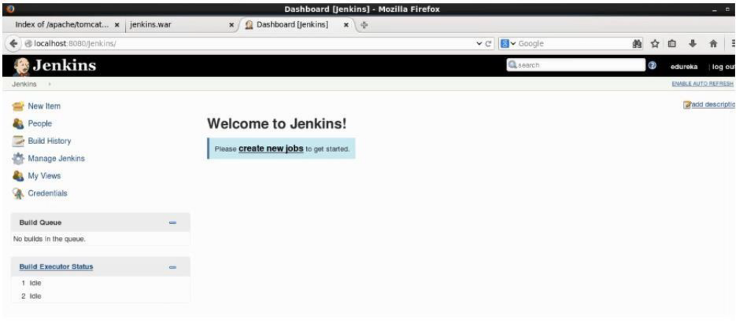

Step 2: Install the required plugins:

- Go to the manage plugins.
- Select the available plugins.
- For deploying install “Deploy to container plugin”.
- For pipeline install “Delivery Pipeline plugin”.
- For Nexus Repository install “Nexus Artifact Uploader”.
- For SonarQube install “SonarQube Scanner plugin”.

Step 3: Install the SonarQube:

  - Install SonarQube from https://www.sonarqube.org/downloads/

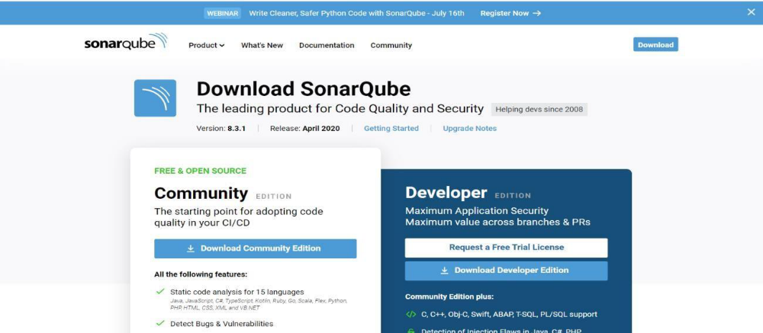

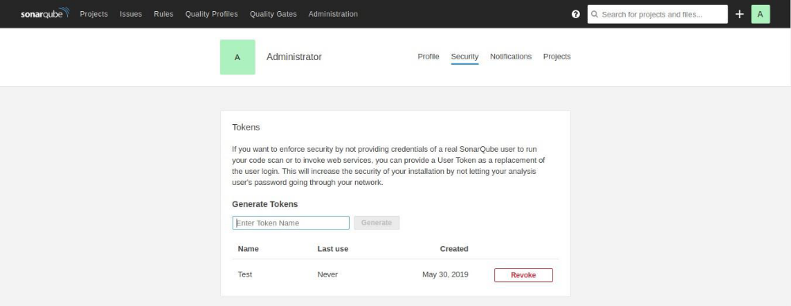

Step 4: Configure SonarQube with Jenkins:

- Go to Manage Jenkins
- Configure Systems
- SonarQube Servers

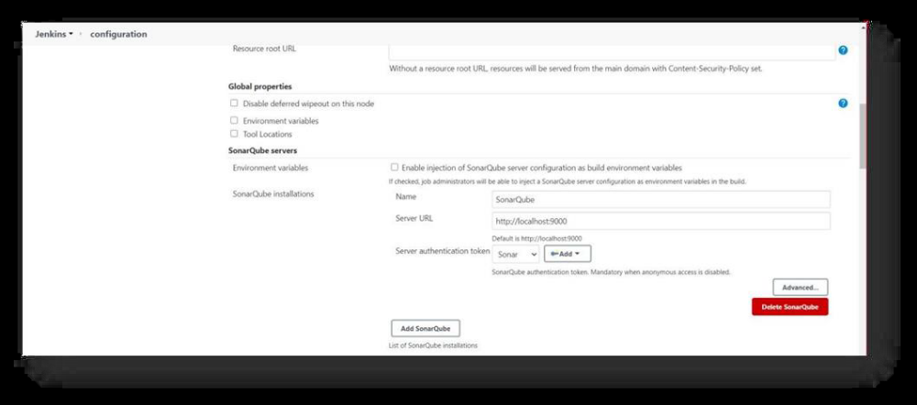

- SonarQube server always run on http://localhost:9000

- Now click on add.

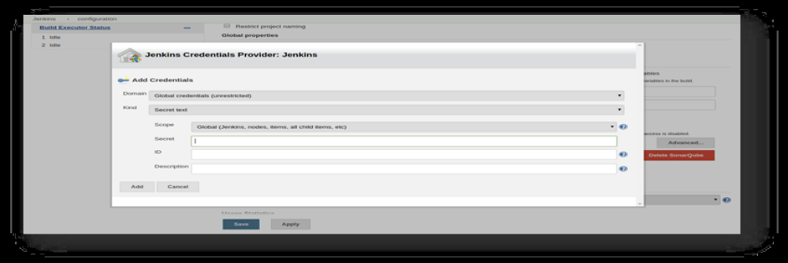

Step 5: Configure Sonar Scanner with Jenkins:

- Download Sonar Scanner from https://docs.sonarqube.org/latest/analysis/scan/sonarscanner/
- Go to Manage Jenkins
- Global Tool Configuration
- SonarQube Scanner

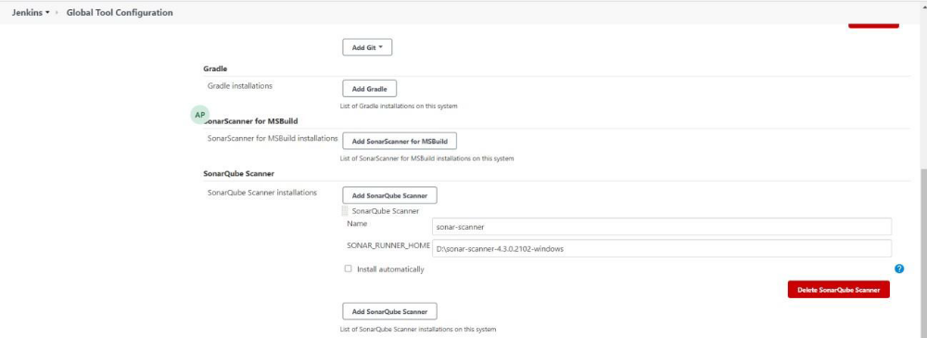

- Here give name and path of the sonar scanner.
- Now apply and save it.

Step 6: Install the Nexus Repository:

- Download Nexus from https://www.sonatype.com/download-oss-sonatype/

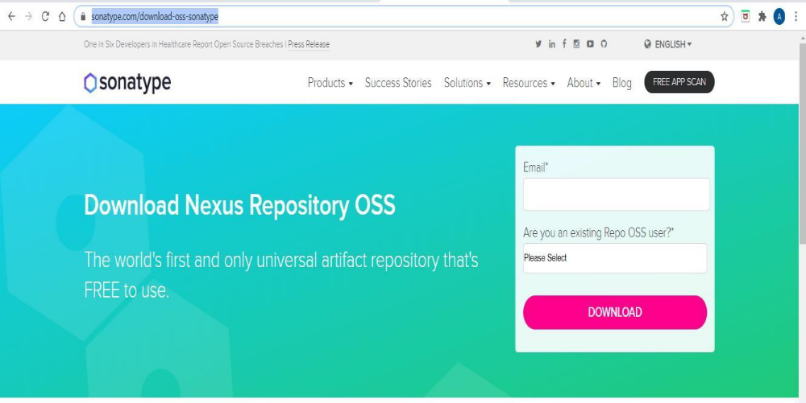

Step 7: Create the freestyle project (without pipeline):

- Select new item.
- Select freestyle project.
- Click on OK.

Step 8: Freestyle Project Configuration:

- Give the path of directory.

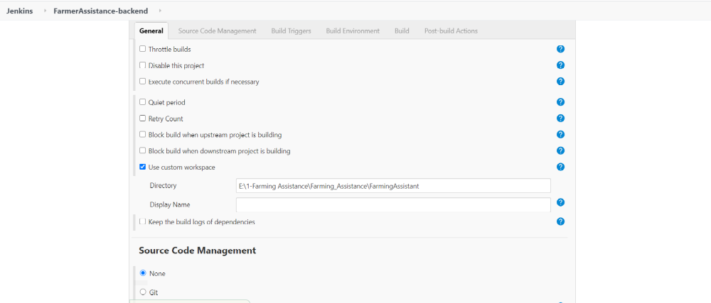

- Build Project:

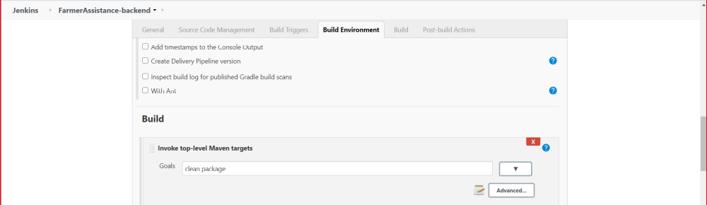

- Add Nexus Repository Details:

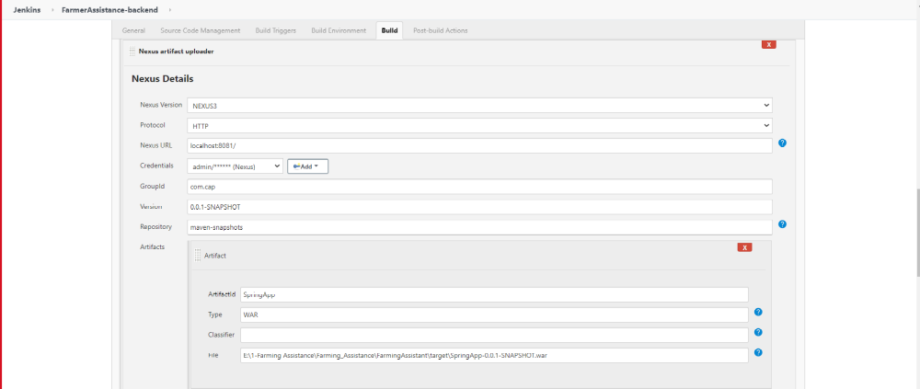

- Add SonarQube details:

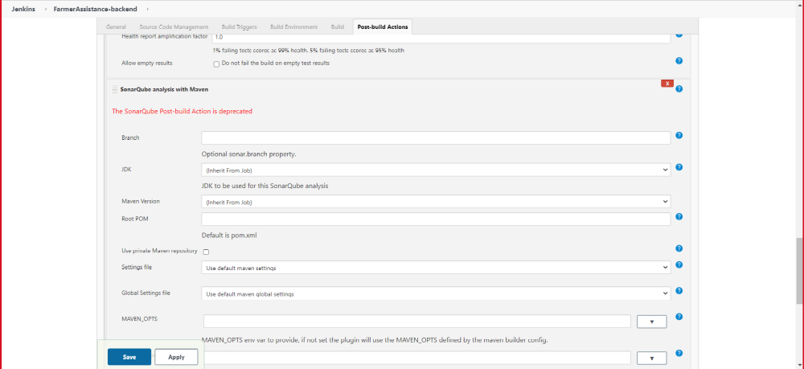

- Deploying the Project:

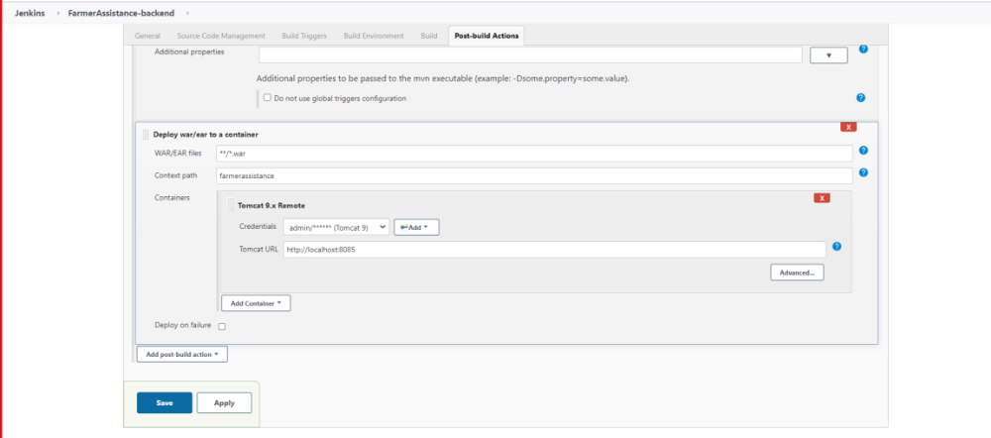

- Build Project:

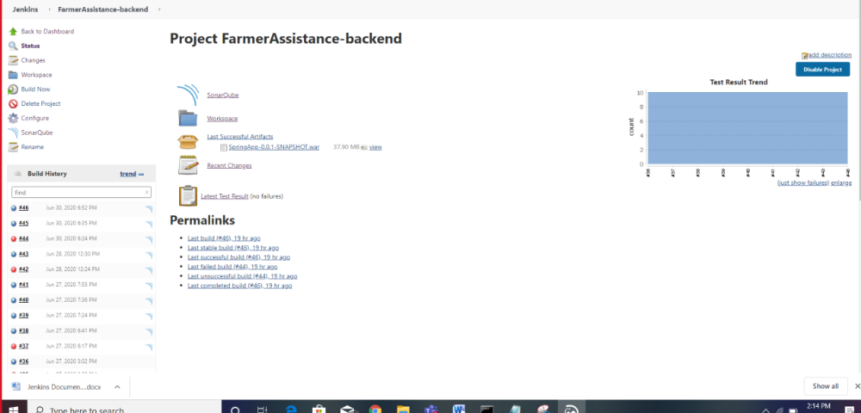

- Console Output:

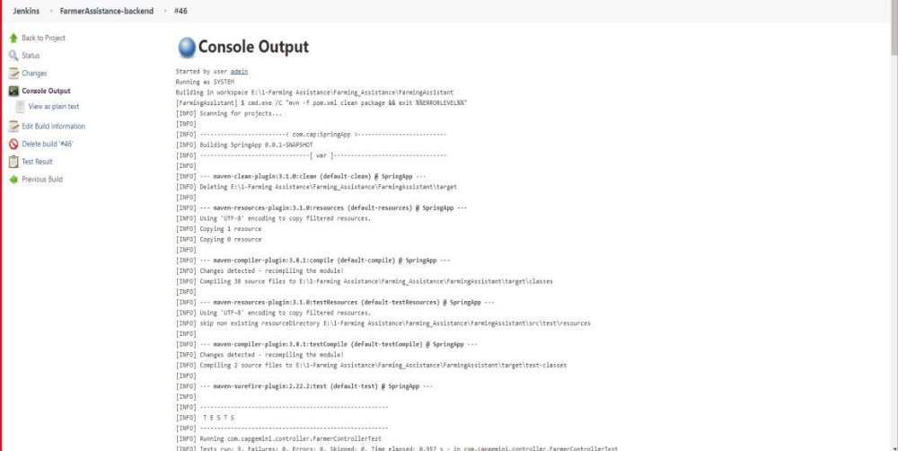

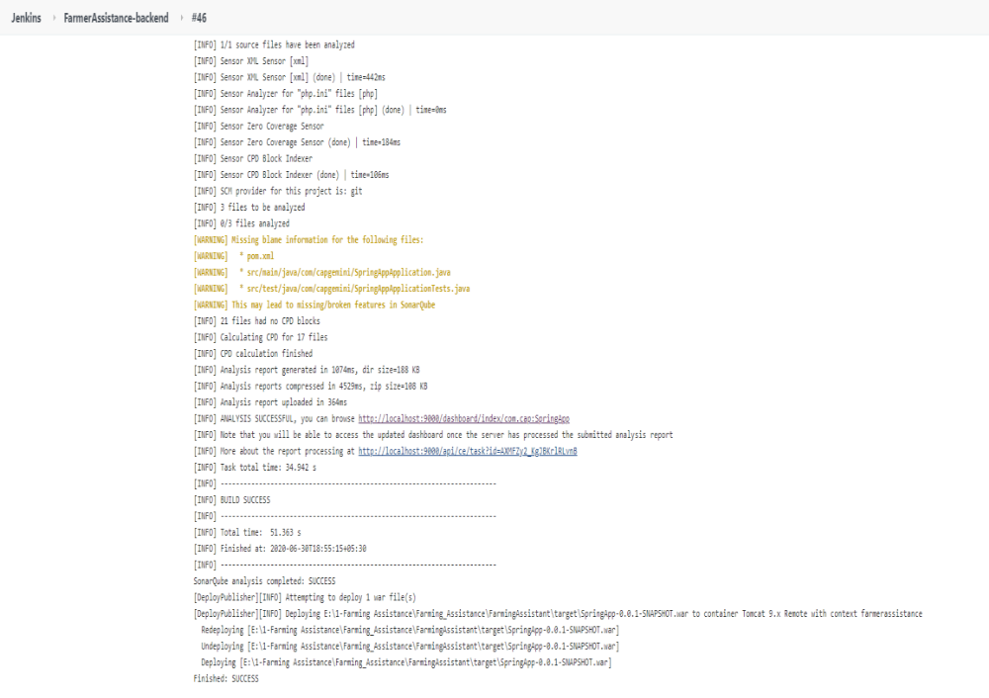

- Artifact saved on Nexus Repository:

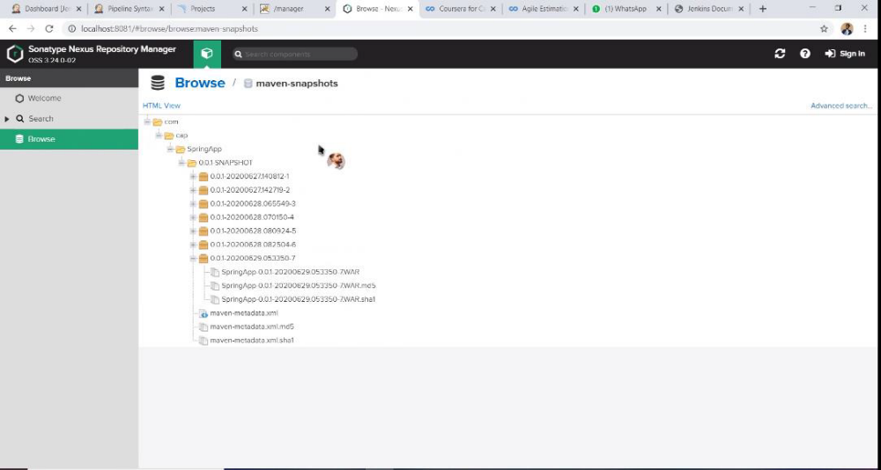

- SonarQube Code Coverage

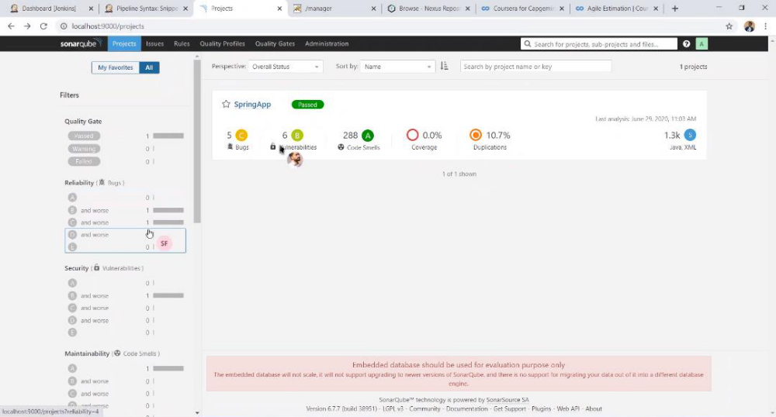

- Deploying on Tomcat:

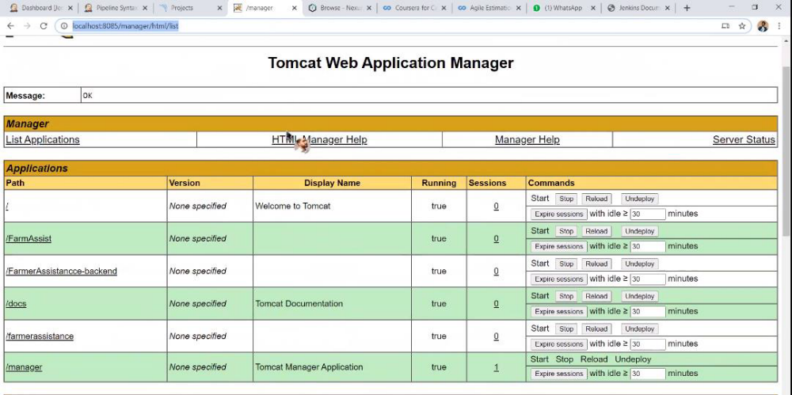

Step 8: Create a Pipeline Project :

- Select new item.
- Select pipeline project.
- Click on OK.
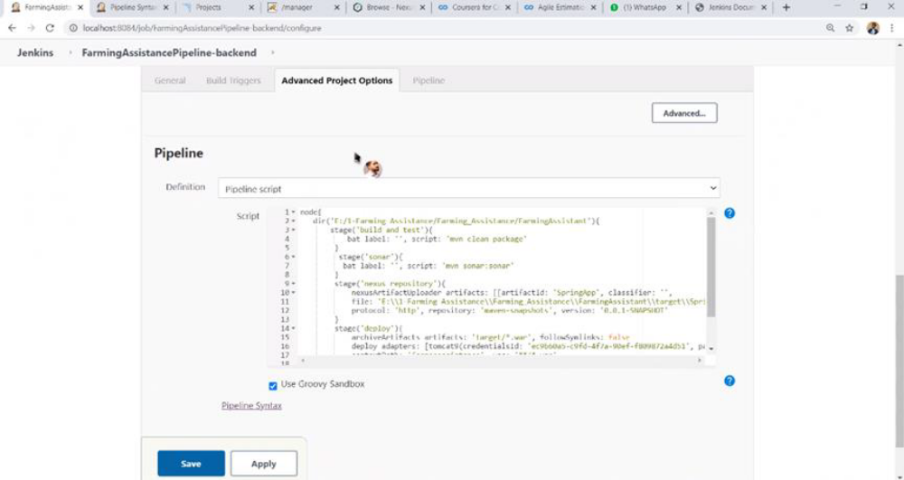
- Click on Configure and generate the pipeline script.

- Output with Pipeline:

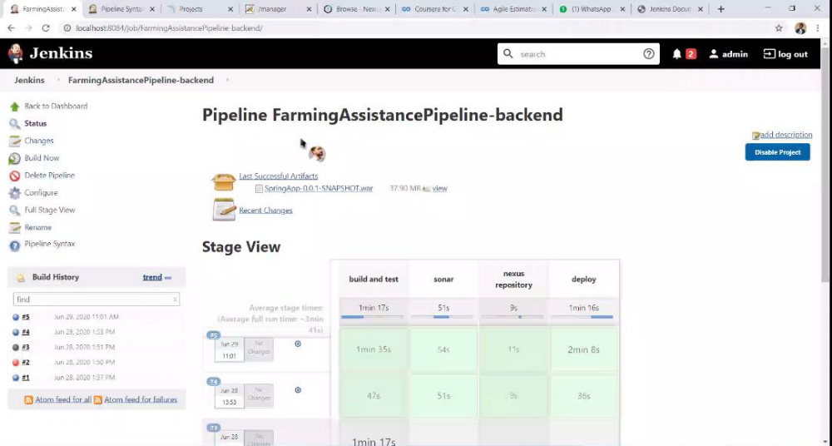

- Console Output:

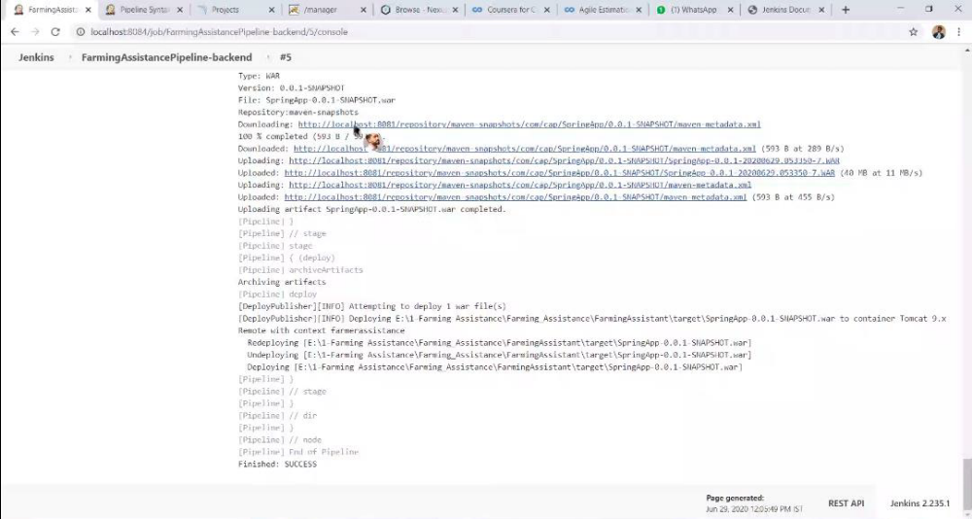

THANK YOU
.

